**LA GRANDEE INTERNATIONAL COLLEGE**

**Simalchour – 8, Pokhara**

Final Project Report

On

**Spa Management System**

**Submitted To:**

LA GRANDEE INTERNATIONAL COLLEGE

Bachelor of Computer Application (BCA) Program

*In partial fulfillment of the requirements for the degree of Program Name under*

**Pokhara University**

**Submitted By:**

|  |  |  |
| --- | --- | --- |
| **Name** | **Program, Semester** | **PU Registration No.** |
| Saroj Baral | BCA IV | 2022-1-53-0143 |
| Srenka Bhandari | BCA IV | 2022-1-53-0146 |
| Sabin Pandey | BCA IV | 2022-1-53-0139 |
| Anish Poudel | BCA IV | 2022-1-53-0118 |

**August ,2023**

# Acknowledgement

We express our sincere regard to our project supervisor **Mr. Nabin Pandey**, DBMS Lecturer **Mr. Amrit Lamsal** and Co-Ordinator **Mr. Ramesh Chalise** for his valuable time, guidance, encouragement, support, and cooperation throughout our project. We would sincerely like to thank the BCA Department for allowing us to work on enhancing our technical skills while undergoing this project.

This is a project proposal report on Spa Management System which is carried out as an ingredient of assignment as specified by the faculty member of the degree of BCA, 4th semester.

We are very thankful that you have provided us with an opportunity to show our talent and to sharpen our knowledge.

With Regards,

Saroj Baral (Reg.no: 2022-1-53-0143)

Srenka Bhandari (Reg.no: 2022-1-53-0146)

Sabin Pandey (Reg.no: 2022-1-53-0139)

Anish Poudel (Reg.no: 2022-1-53-0139)

# Abstract

The proposed project, the "SPA Management System," aims to streamline and simplify the management operations of a SPA facility through a user-friendly desktop application developed using VB.NET and MSSQL. The system caters to both normal users and administrators, offering a range of features to enhance the SPA experience and optimize administrative tasks.

For normal users, the system provides convenient tools such as appointment booking, real-time availability checks, appointment cancellation, and updating appointment information. These features empower users to effortlessly schedule and manage their SPA sessions, ensuring a seamless and enjoyable experience.

For administrators, the system offers comprehensive functionalities to efficiently manage various aspects of the SPA business. This includes the ability to add new services, view transaction records, delete transactions, if necessary, remove services, manage employee schedules and performance, handle miscellaneous services, and oversee user management activities.

By integrating these features into a cohesive desktop application, the SPA Management System not only enhances the operational efficiency of the SPA but also improves customer satisfaction by providing a streamlined and personalized experience. With its intuitive interface and robust functionality, the system is poised to revolutionize the way SPAs are managed and operated, ultimately leading to increased productivity and profitability.

**Declaration for**

**“Spa Management System”**

# Student’s Declaration

This is to certify that Spa Management System embodies the original work done by Saroj Baral and R.A. Mohan Tiwari, which is submitted to LA GRANDEE International College, under the affiliation of Pokhara University. This project is submitted as a partial fulfillment of the requirement for the system development project of the Bachelor of Computer Application 4th semester, under the supervision of Mr. Ramesh Chalise. We further state that no resources other than those specifically listed have been utilized in the completion of the project.

Name: Saroj Baral …………………………

Exam Roll NO: 22530028  **Signature**

Semester: BCA 4th

P.U Registration No: 2022-1-53-0143

Name: Srenka Bhandari ……….……………….

Exam Roll No: 22530031 **Signature**

Semester: BCA 4th

P.U Registration No: 2022-1-53-0136

Name: Sabin Pandey ……….……………….

Exam Roll No: 2253024 **Signature**

Semester: BCA 4th

P.U Registration No: 2022-1-53-0139

Name: Anish Poudel ……….……………….

Exam Roll No: 22530004 **Signature**

Semester: BCA 4th

P.U Registration No: 2022-1-53-0118

# Supervisor’s Declaration

I hereby recommend that his project entitled “**Spa Management System**” is done under my supervision by **Saroj Baral** , **Srenka Bhandari** , **Sabin Pandey** and **Anish Poudel** during the 4th semester in partial fulfillment of the requirement of the degree of Bachelor of Computer Application **(BCA)** under **Pokhara University** is completed to my satisfaction and he processed for final evaluation.

_________________

**Mr. Ramesh Chalise**

**Date: 01/07/2023**



Date: 2024-07-01

…………………………..

**Er. Kiran K.C**

Principal

…………………………..

**Mr. Ramesh Chalise**

Department Coordinator

………………………………….

**Mr Prithivi Raj Paneru**

External Examiner

…………………………..

**Mr. Nabin Pandey**

Supervisor

**Letter of Approval**

We certify that we have examined this report entitled “**SPA Management System**” and are satisfied with the project defense. It is satisfactory in the scope and qualify as project in partial fulfillment of the requirements for the degree of BCA under Pokhara University.

# Project Summary

Spa Management System is a digitalized application to automate all kinds of booking activity in a SPA. The main aim of this program is to view, retrieve, book, and cancel appointments in a SPA. The system provides the staff with a user-friendly interface to view available services, book appointments, and cancel appointments.

The application is designed to be simple and easy to use, making it accessible to any authorized staff with basic computer skills. Customers can easily book their appointments as they can just call and schedule their appointments or can even visit the SPA as it wouldn’t take much time at all.

The SPA appointment system is also designed to be scalable; it can easily be adapted to meet the changing needs of the business. This system is going to be developed using Incremental Methodology which makes it easier to modify the system accordingly. The application is built using VB.NET and MSSQL, which is known for its speed, efficiency, and reliability.

Overall, the Spa Management System developed using VB.NET and MSSQL are powerful tool for Spa businesses to manage their appointments, attract new customers, and increase revenue. The system offers a convenient way for staff to book appointments, and it enables businesses to streamline their operations, reduce administrative costs, and improve customer satisfaction.

# Table of Contents

Acknowledgement ii

Abstract iii

Student’s Declaration iv

Supervisor’s Declaration v

Letter of Approval vi

Project Summary vii

Table of Contents viii

List of Figures x

List of Tables xi

1. Introduction 1

2. Background Study 2

3. Problem Statement 3

4. Requirement Gathering: 4

4.1. Requirement specifications: 4

5. Objectives 5

6. Design: 6

6.1 Data Flow Diagram 6

6.2 Entity Relationship Diagram: 9

6.3 Flowchart: 10

7. Project Gantt Chart 13

8. Methodology 14

9. Implementation 15

9.1 Tools/ Language Used: 15

9.2 Work Assignment 16

10. Testing 17

10.1 Test Case: Admin 17

10.2 Test Case: User 18

11. Project Results 19

12. Future Enhancement 20

13. Conclusion 21

14. Annexures 22

15. References 29

# List of Figures

Fig 6.1-1 DFD level 0 6

Fig 6.1-2 DFD level 1 6

Fig 6.1-3 DFD level 2 Login 7

Fig 6.1-4 DFD level 2 User 8

Fig 6.1-5 DFD level 2 Administrative 8

Fig 6.2-6 E-R Diagram 9

Fig 6.3-7 Select User Interface 10

Fig 6.3-8 Administrative Flowchart 11

Fig 6.3-9 User Flowchart 12

Fig 7-10 Project Gantt Chart 13

Fig 8-11 Incremental Model 14

# List of Tables

Table 9.2-1 Work Division 16

Table 10.1-2 Test Case of Admin 17

Table 10.2-3 Test Case of User 18

# Abbreviations

|  |  |
| --- | --- |
| SPA | Salus Per Aquam |
| BCA | Bachelors in computer application |
| DFD | Data flow diagram |
| IT | Information Technology |
| ER | Entity Relationship |
| ADMIN | Administrator |
| VB.NET | Visual Basic .NET |
| MSSQL | Microsoft SQL |
| SMS | Spa Management System |

# Introduction

In the bustling world of wellness and relaxation, SPAs serve as sanctuaries for individuals seeking respite from the demands of everyday life. However, managing a SPA efficiently involves juggling numerous tasks, from appointment scheduling to employee management and service administration. Recognizing the need for a comprehensive solution to streamline these operations, we propose the development of the SPA Management System (Smith & Wallace, 2020).

The SPA Management System is envisioned as a desktop application crafted using VB.NET and MSSQL, tailored specifically to meet the unique needs of SPA facilities. By harnessing the power of technology, this system aims to simplify and enhance the management process, both for SPA administrators and their clientele.

In this introduction, we provide an overview of the key features and objectives of the SPA Management System, highlighting its potential to revolutionize SPA management practices. From appointment booking and availability checks to transaction tracking and employee management, the system offers a suite of functionalities designed to optimize every aspect of SPA operations.

By leveraging intuitive user interfaces and robust database management capabilities, the SPA Management System promises to elevate the SPA experience for both customers and staff alike. With this innovative solution, SPA administrators can streamline their workflows, maximize efficiency, and ultimately deliver an unparalleled level of service to their patrons.

In the subsequent sections of this proposal, we delve deeper into the specifics of the system architecture, features, and implementation strategy, outlining a roadmap for the successful development and deployment of the SPA Management System. Through collaborative effort and strategic planning, we aim to bring this vision to fruition, ushering in a new era of simplicity and sophistication in SPA management.

# Background Study

The foundation of our project emerged from a relatable incident – a team member's frustration with the time-consuming process of booking Spa appointments. This personal experience became the catalyst for developing a more streamlined approach: the Spa Management System.

Our initial steps involved comprehensive research, combining interviews with industry insiders and individuals who've faced appointment-related challenges. Online resources also provided valuable insights into existing systems. Complementing this digital exploration, we conducted on-site visit to a well famous Spa in town ‘Malama Spa ‘. This visit not only enriched our understanding but also presented practical perspectives on the obstacles both customers and management encounter.

By immersing ourselves in the Spa environment, we gained direct insights into the intricacies of appointment management during varying demand periods. These interactions with Spa personnel underscored the need for improved efficiency and a more user-friendly approach.

This realization fuels our project's mission to bridge these gaps and deliver an innovative Spa Management System, poised to reshape scheduling processes across the industry.

# Problem Statement

* SPA facilities face numerous operational challenges that hinder their ability to deliver seamless services and experiences to clients.
* Manual administrative tasks, inefficient appointment scheduling, and disjointed management processes strain resources and detract from customer satisfaction.
* The absence of a centralized management system tailored to SPA-specific needs leads to missed revenue opportunities, employee dissatisfaction, and customer attrition (Henkin, 2023).
* Administrators struggle with managing bookings, services, transactions, and personnel, while clients may encounter difficulties in securing appointments or accessing desired services promptly (Henkin, 2023).
* Tension due to manual recording, manual appointment booking causes tension as the record book might get lost or get damaged by accident. And it is horrendous work for the staff to check manually recorded appointments.
* Lack of tech adaptation within the SPA management areas, where manual record books or only excels are still used, making it harder for the management to keep track of everything related to management.

# 4. Requirement Gathering:

Requirement Analysis is the first and most important step in the system development activity for building a robust and user-friendly system. While performing surveys and research we came to know that in current scenario, most of the users prefer the traditional ways of booking appointments because they are not aware of the latest technology to manage the overall booking system in more efficient way. They don’t know how to use these sites and, they don’t feel trustworthy.

## 4.1. Requirement specifications:

Mrs. Nisha Budha, the owner of Malama Spa talked about the requirements her Spa was looking for. Below are those requirements of the Spa Management System:

* **Increased efficiency**

The system should be able to operate the Spa’s daily operations like book appointment, cancel appointment, shift schedule, view transactions, edit services being errorless and efficiently.

* **User friendly Interface**

The system should have user-friendly interface that is easy to understand and use.

* **Secured system**

The system should be secured and trustworthy to keep all the data and information of the organization safe.

* **Flexible system**

The system must be flexible in terms of functionality so that the need of other software gets disappeared

# 5. Objectives

The existing appointment management system used by SPAs is often manual, time-consuming, and prone to errors, leading to customer dissatisfaction and revenue loss. The proposed SPA Appointment System application aims to provide an automated and user-friendly interface for the SPA staff to manage their customer appointments efficiently.

**The problems before the proposal of this system were:**

* Enable seamless appointment scheduling.
* Enhance service management.
* Implement robust transaction tracking.
* Ensure administrative control and security.
* Ensure scalability and flexibility.

# 6. Design:

The section of the Design in documentation includes Data Flow Diagrams (DFD), flowcharts, E-R diagram providing a more comprehensive understanding of our system's design.

## 6.1 Data Flow Diagram

#### Fig 6.1-1 DFD level 0

**Index (Level 0 DFD):**

1. – Spa Management System

#### Fig 6.1-2 DFD level 1

**Index (Level 1 DFD):**

1. - Appointment Booking Process

1.1 - Enquiry

1.2 - Update Service

1.3 - Transaction Details

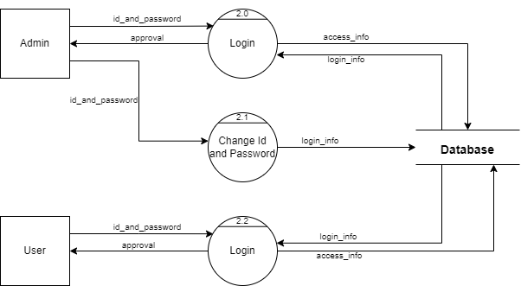

#### Fig 6.1-3 DFD level 2 Login

**Index (Level 2 DFD):**

2.0 - Login

2.1 - Change Id and Password

2.2 – Login

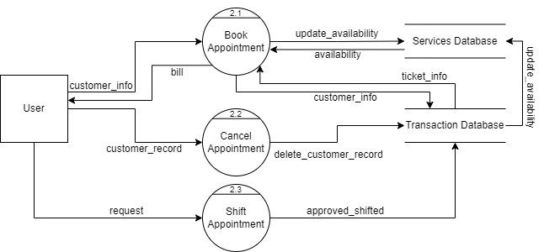

#### Fig 6.1-4 DFD level 2 User

**Index (Level 2 DFD):**

2.1 - Book Appointment

2.2 - Cancel Appointment

2.3 - Shift Appointment

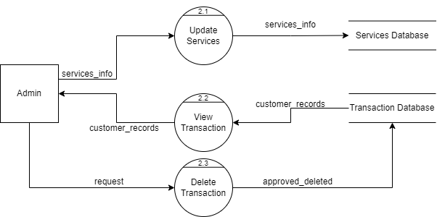

#### Fig 6.1-5 DFD level 2 Administrative

**Index (Level 2 DFD):**

2.1 - Update Services

2.2 - View Transaction

2.3 - Delete Transaction

## 6.2 Entity Relationship Diagram:

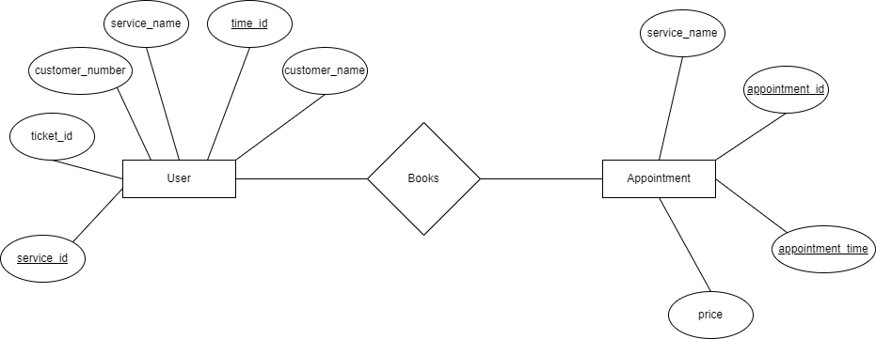

#### Fig 6.2-6 E-R Diagram

## 6.3 Flowchart:

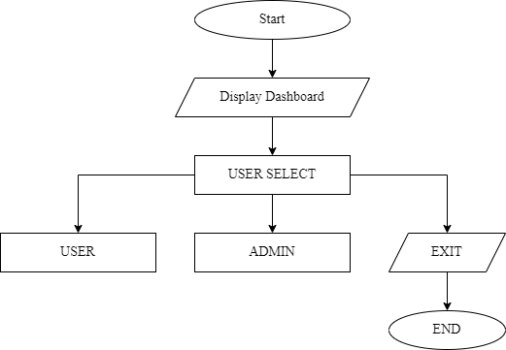

#### Fig 6.3-7 Select User Interface

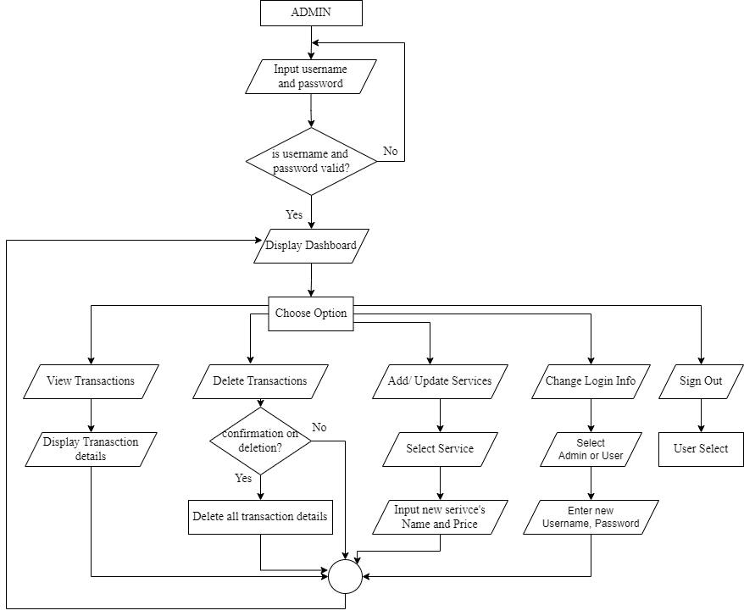

#### Fig 6.3-8 Administrative Flowchart

#### Fig 6.3-9 User Flowchart

# 7. Project Gantt Chart



#### Fig 7-10 Project Gantt Chart

# 8. Methodology

For the development of the “SPA Management system” program, we’ll be using Scrum methodology, an Agile Framework. Scrum is one of the many types of agile methodology, known for breaking projects down into sizable chunks called “sprints.” Agile scrum methodology is good for businesses that need to finish specific projects quickly (Schwaber, What is Scrum?, 2022). Agile scrum methodology is a project management system that relies on incremental development. Each iteration consists of two- to four-week sprints, where the goal of each sprint is to build the most important features first and come out with a potentially deliverable product. More features are built into the product in subsequent sprints and are adjusted. Scrum is a lightweight framework that helps people, teams and organizations generate value through adaptive solutions for complex problems (Schwaber & Sutherland, The 2020 Scrum Guide, 2020).

**In a nutshell, Scrum requires a Scrum Master to foster an environment where:**

1. A Product Owner/ Manager orders the work for a complex problem into a Product Backlog.
2. The Scrum Team turns a selection of the work into an Increment of value during a Sprint.
3. The Scrum Team inspects the results and adjusts for the next Sprint.
4. Repeat

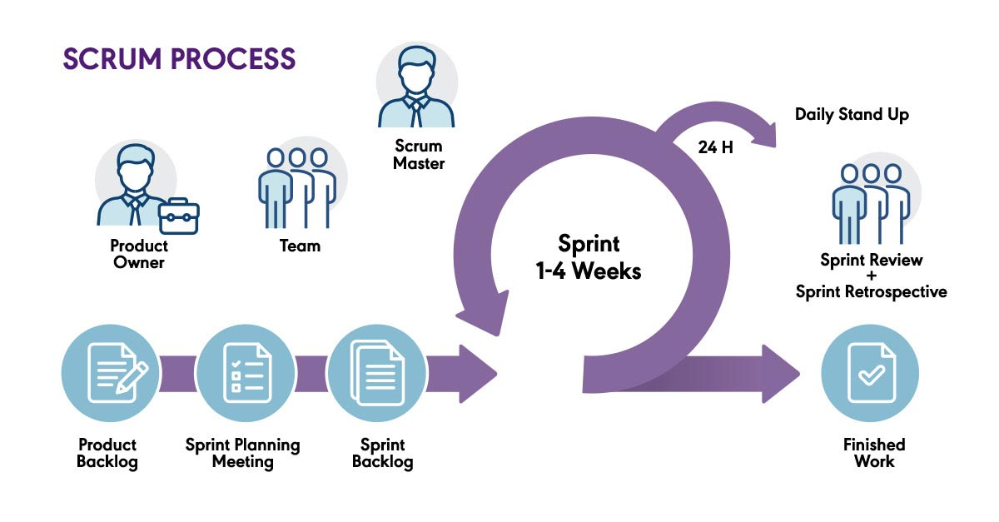

#### Fig 8-11 Scrum Model

# 9. Implementation

## 9.1 Tools/ Language Used:

We chose **Visual Studio Code** (Source-Code Editor) for this project because it provides a simple and user-friendly interface. It made us easy to start writing and testing code. As Visual Studio Code does not include debugging tools, we had to install The GCC (GNU Compiler Collection) which included both complier and debugging tools.

 We have used different tools till date for different purposed. The tools we used are:

* **VB.NET and MSSQL** for source code
* **Draw.io** for DFD, Flowchart and E-R Diagram
* **MS Excel** for Gantt Chart
* **MS PowerPoint** for Presentation
* **MS Word** for Documentation
* **VB.NET** for Coding and Testing
* **Discord** and **WhatsApp** for online meeting

## 9.2 Work Assignment

|  |  |  |
| --- | --- | --- |
| **S.N.** | **NAME** | **WORK ASSIGNED** |
| 1. | Saroj Baral | Coding, System Design, and Documentation   * Coding of major modules like book appointment, login system, schedule shiftment. * File handling * System Designs * Logic definition * Designing of Diagrams |
| 2. | R.A. Mohan Tiwari | Coding, Documentation and Testing   * Coding of modules like View transactions, delete transactions, Edit services * Testing of login systems * System Design support * Documentation * Presentation * Coding support |

#### Table 9.2-1 Work Division

# 10. Testing

Regardless of the development methodology, the goal of testing is to make sure that what is created does what it is supposed to do. We have included testing as a part of the development process. The test cases should be designed with maximum possibilities of finding the errors or bugs.

We have designed and executed a few test cases to check it the application meets the functional requirements.

|  |  |  |  |
| --- | --- | --- | --- |
| **TEST MODULE** | **TEST CASE** | **EXPECTED RESULT** | **TEST RESULT** |
| ADMIN | Signs up with Information for login | User successfully logged in and directed to the admin dashboard page | PASS |
| ADMIN | Enters invalid login credentials | Displays Error message | PASS |
| ADMIN | Enters View Transactions | Checks Transactions & if there is any, displays it or exits | PASS |
| ADMIN | Enters Delete Transactions | Asks for final confirmation (y/n), and format all transactions or for exit. | PASS |
| ADMIN | Enters Add/ Update Services | Asks for choice, and asks for final confirmation (y/n) & asks for service details and saves it or asks for exit | PASS |
| ADMIN | Enters Change Login Information | Asks for new Username and password and saves it | PASS |
| ADMIN | Enters Sign Out | Directs to User Selection dashboard | PASS |

## 10.1 Test Case: Admin

#### Table 10.1-2 Test Case of Admin

## 10.2 Test Case: User

|  |  |  |  |
| --- | --- | --- | --- |
| **TEST** **MODULE** | **TEST CASE** | **EXPECTED RESULT** | **TEST RESULT** |
| USER | Provide details for registration | User successfully registered with the application and directed to the admin page | PASS |
| USER | Enters Book appointment | Asks for choice (Services) or for exit | PASS |
| USER | Enters Cancel appointment | Asks for final confirmation (y/n) and if yes also asks for appointment info (ticket id, phone number) and directs back to User Dashboard | PASS |
| USER | Enters Shift Schedule | Asks for appointment info and also asks for final confirmation and asks for entering another available schedule | PASS |
| USER | Enters Sign out | Directs to User Selection dashboard | PASS |

#### Table 10.2-3 Test Case of User

# 11. Project Results

Our team successfully completed the development of our first project, which involved creating a digital platform for a spa appointment booking system. The primary goal was to modernize and streamline the business operations of spas through various innovative features.

**Key Accomplished Functions:**

In the administrator’s dashboard, we implemented features such as View transactions, delete transactions, add services, change service details, change login information and sign out. On the User side, we introduced functions for booking appointment, cancelling appointment, shifting appointment and sign out.

**Solutions to addressed problems:**

Our project effectively tackled several challenges faced by spas. We resolved issue related to appointment management, security, immediate service updates and the absence of fast booking system.

**Fulfilled Requirements:**

The project met both functional and non- functional requirements set by the spa, except for a selection of date feature as the limitation of Database Management System in C programming language. This aspect is slated for future enhancement. All business objectives, including enhanced efficiency, increased sales, improved customer experiences, security measures and a user-friendly interface, were successfully achieved.

**Benefits for Team Members:**

Our collaborative journey in developing the Spa Appointment Booking System proved to be an invaluable learning experience for all team members involved. This project fostered the growth of a wide array of skills and mindsets that will undoubtedly contribute to our future professional and personal undertakings. It notably bolstered our capabilities in teamwork, technical proficiency, time management and creative problem-solving.

# 12. Future Enhancement

The current Spa Management System that we have developed provides the functionality of booking available appointments, creating account and managing the services in a Spa. The features that can be added to this system in the future are as follows:

* Use better database approaches.
* Add the Specification and benefits of each Spa on the menu.
* Add online payment method.
* Feature for saving User’s feedback in the system.

# 13. Conclusion

The Spa Management System (SMS) is a software solution designed to optimize the operations of a spa. Through features such as appointment booking, cancellation, rescheduling, and service management, SMS contributes to heightened efficiency and productivity. It also facilitates tasks like modifying login credentials, viewing and managing transactions. Both users and administrators benefit from its user-friendly interface and accessibility. Valuable insights for potential enhancements and identified areas for improvement are part of its outcomes. By implementing a Spa Management System using the VB.NET and MSSQL, the overall structure and functioning of a spa can be significantly improved. This improvement extends to better organizational practices, informed decision-making, and an elevated level of customer satisfaction. The central goal of the project was to streamline processes, reduce time consumption, and minimize errors during system administration.

# 14. Annexures

Snapshots of Project Preview:

# 15. References

*File Handling in C*. (2023, June 20). Retrieved from JavatPoint: https://www.javatpoint.com/file-handling-in-c

*JavaPoint*. (2023, 05 2). Retrieved from JavaPoint Software engineering incremental model: https://www.javatpoint.com/software-engineering-incremental-model

SPA, M. (2023, 04 29). *Malama Spa*. Retrieved from Malama Spa: https://www.malamaspa.com/